FOR IMMEDIATE RELEASE
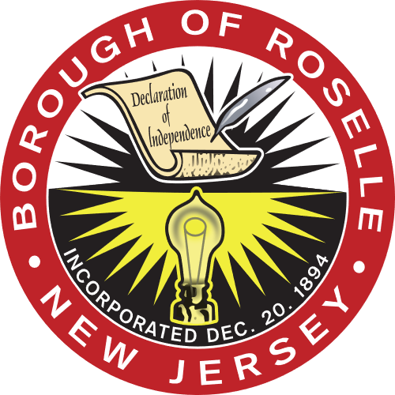

Borough of Roselle Announces COVID-19 Vaccination Policy for Municipal Employees

ROSELLE, NJ - December 23, 2021 – Roselle Mayor Donald Shaw announced today a mandatory COVID-19 vaccination policy for all municipal employees to help safeguard the health and wellness of the Borough in light of the latest increase in pandemic-related illness.

“We are implementing this new policy as a precautionary measure for the Borough to help stay in front of the rise of this new surge,” Mayor Shaw said.

In support of Roselle’s commitment to health and safety for all members of its community, all municipal employees are required to be vaccinated for COVID-19 unless a reasonable accommodation is approved. Employees who are not fully vaccinated in compliance with this policy will be subject to weekly COVID-19 testing.

“The greatest gift we can give our loved ones, community members and Borough staff this year, is to do everything in our power to keep them safe,” said Council President Denise Wilkerson. “We must continue to follow CDC guidelines and take effective safety measures so we can get through this together as a community.”

All employees and visitors are still required to wear face masks in all Borough public spaces regardless of vaccination status. This policy has been instituted through the assistance of the Union County Office of Health Management.

End.

